**Final Project Documentaion**

For this final project I explored a cars dataset. The data had 262 observations with a cars mpg, cylinders, cubic inches of a cylinder, horsepower, weight (in pounds), year, and the region (US, Japan, Europe).

I went through different datasets and realized I was making this hard on myself with the amount of variables and big data. So I looked for a dataset, that was had a decent amount of observations and few variables. I came across this cars dataset.With this data set, I decided to study the relationship between horsepower and mpg. This type of comparison would best result from a scatterplot with one variable on the x axis and one variable on the y axis. Once I got the basis working. I decided to separate the points by their region. The simplest way of doing this was by color coding the points by region. This lets the viewer easily distinguish all the points on the plot by region as well. Using d3, there is no automatic legend so the next step was building a legend for the plot. I chose RBG colors as they are the most easily distinguishable with one another. Hovering over the plot, allows one to see the mpg, horsepower, and region. Something I wish I could have added was a line of best fit, but that was beyond my scope at the moment. I was thinking of different questions to visualize, but it grew complicated on with what I wanted to show (i.e boxplots, clustered bar charts etc). I did include another visualization that showed the average mpg of each country. I feel like this was a good thing to know after our findings from our previous visualizations. This visualization includes our three categories of region on the x-axis while including mpg on the y-axis. I did not include color on this as I felt it was only a simple bar chart with 3 bars. I was not able to include this visualization to a public page for some reason. Due to time constraints, I only publiscized the scatterplot but will show the bar chart in the youtube video and this documentation.

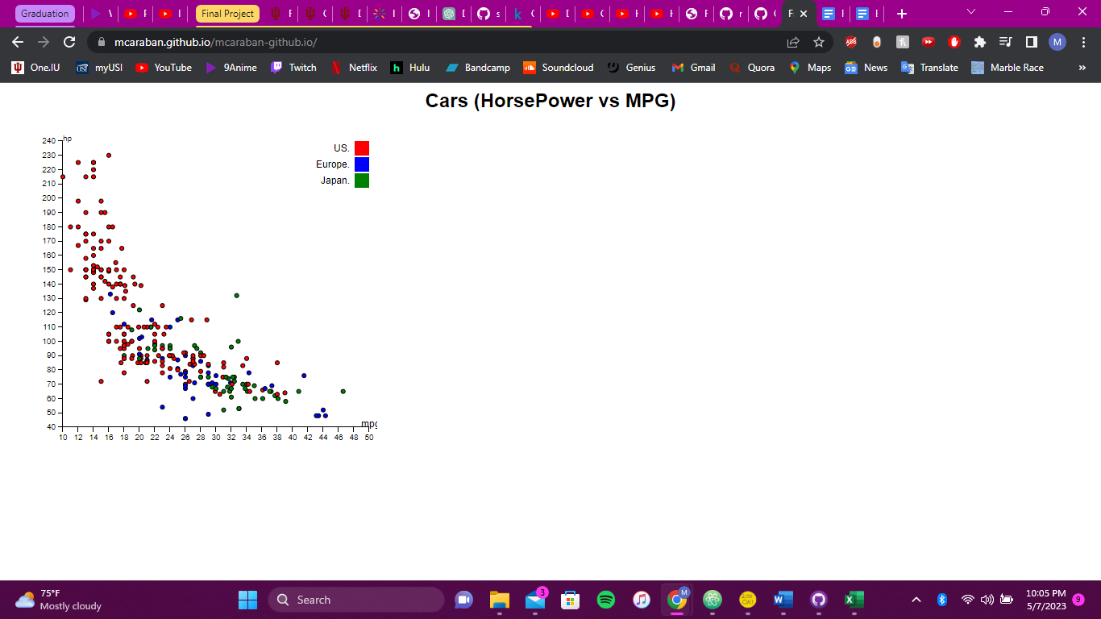

From the scatterplot, we discover that there is a negative relationship between horsepower and mpg. This seems reasonable as the more power a car needs to move, the more gas will be consumed. We can also see that the US in general has higher horsepower vehicles which leds to them also having less fuel efficient vehicles. The opposite cane be said Japan. Their cars in general had more mpg but less horsepower. The European cars are not too far from Japan as they had 3 of the 4 most fuel efficient cars, but the most fuel efficient car was Japanese and also had more horsepower than the 3. In terms of fuel effiecieny Japan is the most successful having an average of 30.21 mpg, while the US expectdly had the least with 19.63 mpg.

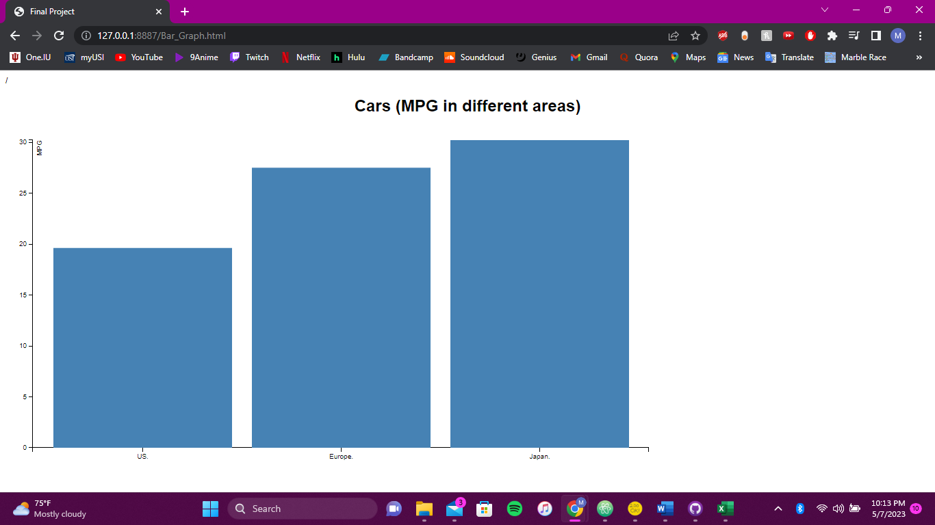

Youtube: <https://www.youtube.com/watch?v=G3mqjgwKDQk&ab_channel=MichaelCarabantes>